参考：[www.cnblogs.com/sunniest/p/4555801.html](http://www.cnblogs.com/sunniest/p/4555801.html)

**SpringMVC学习笔记----**

**一、SpringMVC基础入门，创建一个HelloWorld程序**

1.首先，导入SpringMVC需要的jar包。

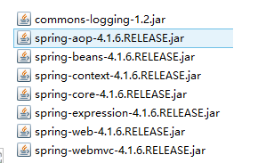

2.添加Web.xml配置文件中关于SpringMVC的配置

<!--configure the setting of springmvcDispatcherServlet and configure the mapping-->

<servlet>

<servlet-name>springmvc</servlet-name>

<servlet-class>org.springframework.web.servlet.DispatcherServlet</servlet-class>

<init-param>

<param-name>contextConfigLocation</param-name>

<param-value>classpath:springmvc-servlet.xml</param-value>

</init-param>

<!-- <load-on-startup>1</load-on-startup> -->

</servlet>

<servlet-mapping>

<servlet-name>springmvc</servlet-name>

<url-pattern>/</url-pattern>

</servlet-mapping>

3.在src下添加springmvc-servlet.xml配置文件

<?xml version="1.0" encoding="UTF-8"?>

<beans xmlns="http://www.springframework.org/schema/beans"

xmlns:xsi="http://www.w3.org/2001/XMLSchema-instance"

xmlns:context="http://www.springframework.org/schema/context"

xmlns:mvc="http://www.springframework.org/schema/mvc"

xsi:schemaLocation="http://www.springframework.org/schema/beans http://www.springframework.org/schema/beans/spring-beans.xsd

http://www.springframework.org/schema/context http://www.springframework.org/schema/context/spring-context-4.1.xsd

http://www.springframework.org/schema/mvc http://www.springframework.org/schema/mvc/spring-mvc-4.1.xsd">

<!-- scan the package and the sub package -->

<context:component-scan base-package="test.SpringMVC"/>

<!-- don't handle the static resource -->

<mvc:default-servlet-handler />

<!-- if you use annotation you must configure following setting -->

<mvc:annotation-driven />

<!-- configure the InternalResourceViewResolver -->

<bean class="org.springframework.web.servlet.view.InternalResourceViewResolver"

id="internalResourceViewResolver">

<!-- 前缀 -->

<property name="prefix" value="/WEB-INF/jsp/" />

<!-- 后缀 -->

<property name="suffix" value=".jsp" />

</bean>

</beans>

4.在WEB-INF文件夹下创建名为jsp的文件夹，用来存放jsp视图。创建一个hello.jsp，在body中添加“Hello World”。

5.建立包及Controller，如下所示

6.编写Controller代码

@Controller

@RequestMapping("/mvc")

public class mvcController {

@RequestMapping("/hello")

public String hello(){

return "hello";

}

}

7.启动服务器，键入 http://localhost:8080/项目名/mvc/hello

**二、配置解析**

1.Dispatcherservlet

　　DispatcherServlet是前置控制器，配置在web.xml文件中的。拦截匹配的请求，Servlet拦截匹配规则要自已定义，把拦截下来的请求，依据相应的规则分发到目标Controller来处理，是配置spring MVC的第一步。

2.InternalResourceViewResolver

　　视图名称解析器

3.以上出现的注解

@Controller 负责注册一个bean 到spring 上下文中

@RequestMapping 注解为控制器指定可以处理哪些 URL 请求

**三、SpringMVC常用注解**

@Controller

　　负责注册一个bean 到spring 上下文中  
@RequestMapping

　　注解为控制器指定可以处理哪些 URL 请求  
@RequestBody

　　该注解用于读取Request请求的body部分数据，使用系统默认配置的HttpMessageConverter进行解析，然后把相应的数据绑定到要返回的对象上 ,再把HttpMessageConverter返回的对象数据绑定到 controller中方法的参数上

@ResponseBody

　　 该注解用于将Controller的方法返回的对象，通过适当的HttpMessageConverter转换为指定格式后，写入到Response对象的body数据区

@ModelAttribute

　　在方法定义上使用 @ModelAttribute 注解：Spring MVC 在调用目标处理方法前，会先逐个调用在方法级上标注了@ModelAttribute 的方法

　　在方法的入参前使用 @ModelAttribute 注解：可以从隐含对象中获取隐含的模型数据中获取对象，再将请求参数 –绑定到对象中，再传入入参将方法入参对象添加到模型中

@RequestParam

　　在处理方法入参处使用 @RequestParam 可以把请求参 数传递给请求方法

@PathVariable

　　绑定 URL 占位符到入参  
@ExceptionHandler

　　注解到方法上，出现异常时会执行该方法  
@ControllerAdvice

　　使一个Contoller成为全局的异常处理类，类中用@ExceptionHandler方法注解的方法可以处理所有Controller发生的异常

**四、自动匹配参数**

//match automatically

@RequestMapping("/person")

public String toPerson(String name,double age){

System.out.println(name+" "+age);

return "hello";

}

**五、自动装箱**

1.编写一个Person实体类

package test.SpringMVC.model;

public class Person {

public String getName() {

return name;

}

public void setName(String name) {

this.name = name;

}

public int getAge() {

return age;

}

public void setAge(int age) {

this.age = age;

}

private String name;

private int age;

}

2.在Controller里编写方法

//boxing automatically

@RequestMapping("/person1")

public String toPerson(Person p){

System.out.println(p.getName()+" "+p.getAge());

return "hello";

}

**六、使用InitBinder来处理Date类型的参数**

//the parameter was converted in initBinder

@RequestMapping("/date")

public String date(Date date){

System.out.println(date);

return "hello";

}

//At the time of initialization,convert the type "String" to type "date"

@InitBinder

public void initBinder(ServletRequestDataBinder binder){

binder.registerCustomEditor(Date.class, new CustomDateEditor(new SimpleDateFormat("yyyy-MM-dd"),

true));

}

**七、向前台传递参数**

//pass the parameters to front-end //可能需要ResponseBody注解，或者可能需要其他的配置

@RequestMapping("/show")

public String showPerson(Map<String,Object> map){

Person p =new Person();

map.put("p", p);

p.setAge(20);

p.setName("jayjay");

return "show";

}

前台可在Request域中取到"p"

**八、使用Ajax调用**

//pass the parameters to front-end using ajax

@RequestMapping("/getPerson")

public void getPerson(String name,PrintWriter pw){

pw.write("hello,"+name);

}

@RequestMapping("/name")

public String sayHello(){

return "name";

}

前台用下面的Jquery代码调用

$(function(){

$("#btn").click(function(){

$.post("mvc/getPerson",{name:$("#name").val()},function(data){

alert(data);

});

});

});

**九、在Controller中使用redirect方式处理请求**

//redirect

@RequestMapping("/redirect")

public String redirect(){

~~return "redirect:hello";~~

}

**十、文件上传**

1.需要导入两个jar包

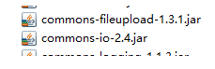

2.在SpringMVC配置文件中加入

<!-- upload settings -->

<bean id="multipartResolver" class="org.springframework.web.multipart.commons.CommonsMultipartResolver">

<property name="maxUploadSize" value="102400000"></property>

</bean>

3.方法代码

@RequestMapping(value="/upload",method=RequestMethod.POST)

public String upload(HttpServletRequest req) throws Exception{

MultipartHttpServletRequest mreq = (MultipartHttpServletRequest)req;

MultipartFile file = mreq.getFile("file");

String fileName = file.getOriginalFilename();

SimpleDateFormat sdf = new SimpleDateFormat("yyyyMMddHHmmss");

FileOutputStream fos = new FileOutputStream(req.getSession().getServletContext().getRealPath("/")+

"upload/"+sdf.format(new Date())+fileName.substring(fileName.lastIndexOf('.')));

fos.write(file.getBytes());

fos.flush();

fos.close();

return "hello";

}

4.前台form表单

<form action="mvc/upload" method="post" enctype="multipart/form-data">

<input type="file" name="file"><br>

<input type="submit" value="submit">

</form>

**十一、使用@RequestParam注解指定参数的name**

//指定了名字后就不需要非要按照顺序传递参数了，否则参数的顺序也要匹配

@Controller

@RequestMapping("/test")

public class mvcController1 {

@RequestMapping(value="/param")

public String testRequestParam(@RequestParam(value="id") Integer id,

@RequestParam(value="name")String name){

System.out.println(id+" "+name);

return "/hello";

}

}

**十二、RESTFul风格的SringMVC**

1.RestController

@Controller

@RequestMapping("/rest")

public class RestController {

@RequestMapping(value="/user/{id}",method=RequestMethod.GET)

public String get(@PathVariable("id") Integer id){//路径占位符参数

System.out.println("get"+id);

return "/hello";

}

@RequestMapping(value="/user/{id}",method=RequestMethod.POST)

public String post(@PathVariable("id") Integer id){

System.out.println("post"+id);

return "/hello";

}

@RequestMapping(value="/user/{id}",method=RequestMethod.PUT)

public String put(@PathVariable("id") Integer id){

System.out.println("put"+id);

return "/hello";

}

@RequestMapping(value="/user/{id}",method=RequestMethod.DELETE)

public String delete(@PathVariable("id") Integer id){

System.out.println("delete"+id);

return "/hello";

}

}

2.form表单发送put和delete请求

在web.xml中配置

<!-- configure the HiddenHttpMethodFilter,convert the post method to put or delete -->

<filter>

<filter-name>HiddenHttpMethodFilter</filter-name>

<filter-class>org.springframework.web.filter.HiddenHttpMethodFilter</filter-class>

</filter>

<filter-mapping>

<filter-name>HiddenHttpMethodFilter</filter-name>

<url-pattern>/*</url-pattern>

</filter-mapping>

在前台可以用以下代码产生请求

<form action="rest/user/1" method="post">

<input type="hidden" name="_method" value="PUT">

<input type="submit" value="put">

</form>

<form action="rest/user/1" method="post">

<input type="submit" value="post">

</form>

<form action="rest/user/1" method="get">

<input type="submit" value="get">

</form>

<form action="rest/user/1" method="post">

<input type="hidden" name="_method" value="DELETE">

<input type="submit" value="delete">

</form>

**十三、返回json格式的字符串**

1.导入以下jar包

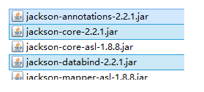

2.方法代码

@Controller

@RequestMapping("/json")

public class jsonController {

@ResponseBody

@RequestMapping("/user")

public User get(){

User u = new User();

u.setId(1);

u.setName("jayjay");

u.setBirth(new Date());

return u;

}

}

**十四、异常的处理**

1.处理局部异常（Controller内）

@ExceptionHandler

public ModelAndView exceptionHandler(Exception ex){

ModelAndView mv = new ModelAndView("error");

mv.addObject("exception", ex);

System.out.println("in testExceptionHandler");

return mv;

}

@RequestMapping("/error")

public String error(){

int i = 5/0;

return "hello";

}

2.处理全局异常（所有Controller）

@ControllerAdvice

public class testControllerAdvice {

@ExceptionHandler

public ModelAndView exceptionHandler(Exception ex){

ModelAndView mv = new ModelAndView("error");

mv.addObject("exception", ex);

System.out.println("in testControllerAdvice");

return mv;

}

}

3.另一种处理全局异常的方法

在SpringMVC配置文件中配置

<!-- configure SimpleMappingExceptionResolver -->

<bean class="org.springframework.web.servlet.handler.SimpleMappingExceptionResolver">

<property name="exceptionMappings">

<props>

<prop key="java.lang.ArithmeticException">error</prop>

</props>

</property>

</bean>

error是出错页面

**十五、设置一个自定义拦截器**

1.创建一个MyInterceptor类，并实现HandlerInterceptor接口

public class MyInterceptor implements HandlerInterceptor {

@Override

public void afterCompletion(HttpServletRequest arg0,

HttpServletResponse arg1, Object arg2, Exception arg3)

throws Exception {

System.out.println("afterCompletion");

}

@Override

public void postHandle(HttpServletRequest arg0, HttpServletResponse arg1, Object arg2, ModelAndView arg3) throws Exception {

System.out.println("postHandle");

}

@Override

public boolean preHandle(HttpServletRequest arg0, HttpServletResponse arg1,

Object arg2) throws Exception {

System.out.println("preHandle");

return true;

}

}

2.在SpringMVC的配置文件中配置

<!-- interceptor setting -->

<mvc:interceptors>

<mvc:interceptor>

<mvc:mapping path="/mvc/**"/>

<bean class="test.SpringMVC.Interceptor.MyInterceptor"></bean>

</mvc:interceptor>

</mvc:interceptors>

3.拦截器执行顺序

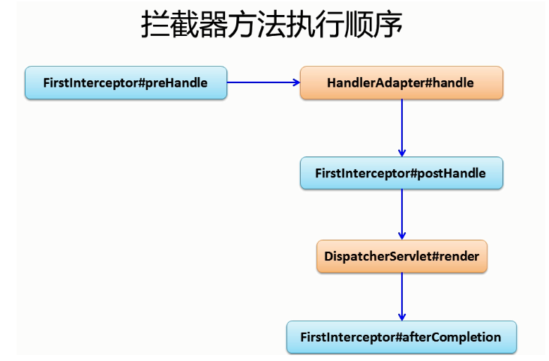

**十六、表单的验证（使用Hibernate-validate）及国际化**

1. 导入Hibernate-validate需要的jar包

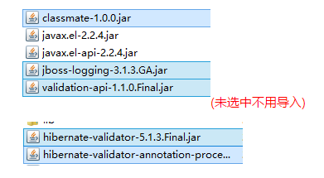

2.编写实体类User并加上验证注解

public class User {

public int getId() {

return id;

}

public void setId(int id) {

this.id = id;

}

public String getName() {

return name;

}

public void setName(String name) {

this.name = name;

}

public Date getBirth() {

return birth;

}

public void setBirth(Date birth) {

this.birth = birth;

}

@Override

public String toString() {

return "User [id=" + id + ", name=" + name + ", birth=" + birth + "]";

}

private int id;

@NotEmpty

private String name;

@Past

@DateTimeFormat(pattern="yyyy-MM-dd")

private Date birth;

}

ps:@Past表示时间必须是一个过去值

3.在jsp中使用SpringMVC的form表单

<form:form action="form/add" method="post" modelAttribute="user">

id:<form:input path="id"/><form:errors path="id"/><br>

name:<form:input path="name"/><form:errors path="name"/><br>

birth:<form:input path="birth"/><form:errors path="birth"/>

<input type="submit" value="submit">

</form:form>

ps:path对应name

4.Controller中代码

@Controller

@RequestMapping("/form")

public class formController {

@RequestMapping(value="/add",method=RequestMethod.POST)

public String add(@Valid User u,BindingResult br){

if(br.getErrorCount()>0){

return "addUser";

}

return "showUser";

}

@RequestMapping(value="/add",method=RequestMethod.GET)

public String add(Map<String,Object> map){

map.put("user",new User());

return "addUser";

}

}

ps:

　　1.因为jsp中使用了modelAttribute属性，所以必须在request域中有一个"user".

　　2.@Valid 表示按照在实体上标记的注解验证参数

　　3.返回到原页面错误信息回回显，表单也会回显

5.错误信息自定义

在src目录下添加locale.properties

NotEmpty.user.name=name can't not be empty

Past.user.birth=birth should be a past value

DateTimeFormat.user.birth=the format of input is wrong

typeMismatch.user.birth=the format of input is wrong

typeMismatch.user.id=the format of input is wrong

在SpringMVC配置文件中配置

<!-- configure the locale resource -->

<bean id="messageSource" class="org.springframework.context.support.ResourceBundleMessageSource">

<property name="basename" value="locale"></property>

</bean>

6.国际化显示

在src下添加locale_zh_CN.properties

username=账号

password=密码

locale.properties中添加

username=user name

password=password

创建一个locale.jsp

<body>

<fmt:message key="username"></fmt:message>

<fmt:message key="password"></fmt:message>

</body>

在SpringMVC中配置

<!-- make the jsp page can be visited -->

<mvc:view-controller path="/locale" view-name="locale"/>

让locale.jsp在WEB-INF下也能直接访问

最后，访问locale.jsp，切换浏览器语言，能看到账号和密码的语言也切换了

**十七、压轴大戏--整合SpringIOC和SpringMVC**

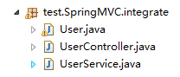

1.创建一个test.SpringMVC.integrate的包用来演示整合，并创建各类

2.User实体类

public class User {

public int getId() {

return id;

}

public void setId(int id) {

this.id = id;

}

public String getName() {

return name;

}

public void setName(String name) {

this.name = name;

}

public Date getBirth() {

return birth;

}

public void setBirth(Date birth) {

this.birth = birth;

}

@Override

public String toString() {

return "User [id=" + id + ", name=" + name + ", birth=" + birth + "]";

}

private int id;

@NotEmpty

private String name;

@Past

@DateTimeFormat(pattern="yyyy-MM-dd")

private Date birth;

}

3.UserService类

@Component  
public class UserService {

public UserService(){

System.out.println("UserService Constructor...\n\n\n\n\n\n");

}

public void save(){

System.out.println("save");

}

}

4.UserController

@Controller

@RequestMapping("/integrate")

public class UserController {

@Autowired

private UserService userService;

@RequestMapping("/user")

public String saveUser(@RequestBody @ModelAttribute User u){

System.out.println(u);

userService.save();

return "hello";

}

}

5.Spring配置文件

在src目录下创建SpringIOC的配置文件applicationContext.xml

<?xml version="1.0" encoding="UTF-8"?>

<beans xmlns="http://www.springframework.org/schema/beans"

xmlns:xsi="http://www.w3.org/2001/XMLSchema-instance"

xsi:schemaLocation="http://www.springframework.org/schema/beans

http://www.springframework.org/schema/beans/spring-beans.xsd

http://www.springframework.org/schema/util

http://www.springframework.org/schema/util/spring-util-4.0.xsd

http://www.springframework.org/schema/context

http://www.springframework.org/schema/context/spring-context.xsd

"

xmlns:util="http://www.springframework.org/schema/util"

xmlns:p="http://www.springframework.org/schema/p"

xmlns:context="http://www.springframework.org/schema/context"

>

<context:component-scan base-package="test.SpringMVC.integrate">

<context:exclude-filter type="annotation"

expression="org.springframework.stereotype.Controller"/>

<context:exclude-filter type="annotation"

expression="org.springframework.web.bind.annotation.ControllerAdvice"/>

</context:component-scan>

</beans>

在Web.xml中添加配置

<!-- configure the springIOC -->

<listener>

<listener-class>org.springframework.web.context.ContextLoaderListener</listener-class>

</listener>

<context-param>

<param-name>contextConfigLocation</param-name>

<param-value>classpath:applicationContext.xml</param-value>

</context-param>

6.在SpringMVC中进行一些配置，防止SpringMVC和SpringIOC对同一个对象的管理重合

<!-- scan the package and the sub package -->

<context:component-scan base-package="test.SpringMVC.integrate">

<context:include-filter type="annotation"

expression="org.springframework.stereotype.Controller"/>

<context:include-filter type="annotation"

expression="org.springframework.web.bind.annotation.ControllerAdvice"/>

</context:component-scan>

**十八、SpringMVC详细运行流程图**

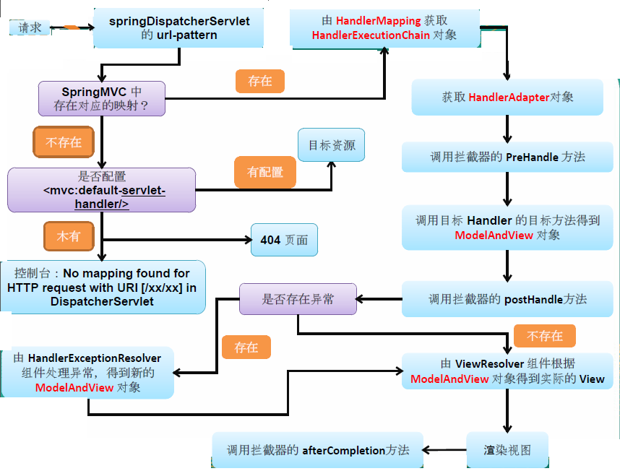

**十九、SpringMVC运行原理**

1. 客户端请求提交到DispatcherServlet  
2. 由DispatcherServlet控制器查询一个或多个HandlerMapping，找到处理请求的Controller  
3. DispatcherServlet将请求提交到Controller  
4. Controller调用业务逻辑处理后，返回ModelAndView  
5. DispatcherServlet查询一个或多个ViewResoler视图解析器，找到ModelAndView指定的视图  
6. 视图负责将结果显示到客户端

**二十、SpringMVC与struts2的区别**

1、springmvc基于方法开发的，struts2基于类开发的。springmvc将url和controller里的方法映射。映射成功后springmvc生成一个Handler对象，对象中只包括了一个method。方法执行结束，形参数据销毁。springmvc的controller开发类似web service开发。  
2、springmvc可以进行单例开发，并且建议使用单例开发，struts2通过类的成员变量接收参数，无法使用单例，只能使用多例。  
3、经过实际测试，struts2速度慢，在于使用struts标签，如果使用struts建议使用jstl。